 

**HIC Introduces Cat Cora by Cutlery Pro® to its Family of Brands**

Cat Cora, renowned as the first female Iron Chef, has brought her culinary expertise and passion for cooking into the world of kitchen tools with her brand, Cat Cora by Cutlery Pro®. This product line empowers home chefs to create their masterpieces easily and precisely.

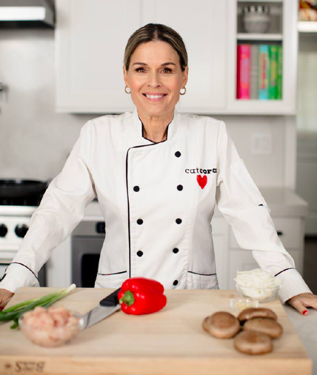

Cat Cora by Cutlery Pro®, is now part of HIC’s Family of Brands and features a diverse range of cutlery, including both forged and soft grip options, as well as garnishing tools and other essential kitchen accessories. Each piece is meticulously crafted from high-quality materials, all known for their exceptional durability, sharpness, and performance. This ensures that every item not only meets, but exceeds, the expectations of both amateur cooks and seasoned chefs alike.

What sets Cat Cora by Cutlery Pro® apart is its commitment to offering premium quality at an accessible price point. This makes it possible for everyone to experience the joy of cooking with professional-grade tools without breaking the bank.

Whether you're slicing, dicing, or garnishing, Cat Cora by Cutlery Pro® provides the perfect balance of form and function, allowing you to unleash your culinary creativity and craft dishes that are as beautiful as they are delicious. With Cat Cora's signature touch, these tools are more than just kitchen essentials; they are an invitation to explore the art of cooking with confidence and flair.

*“Welcome to the world of culinary excellence with Cat Cora by Cutlery Pro®! I’m thrilled to invite you to experience our range of premium cutlery and tools, crafted from high-quality materials. Whether you are a seasoned chef or a home cook, our products are designed to inspire creativity and elevate your cooking experience, all at an accessible price. Let's create masterpieces together!” – Cat Cora*

The new Cat Cora by Cutlery Pro® collection is available exclusively from HIC – Harold Import Co. includes:

|  |  |
| --- | --- |
|  | The **Forged Cutlery Series** is made from high-quality German steel alloy blades and is designed with a full tang. The single piece cutlery features hot drop forged construction and a heavy-duty forged bolster to provide precision during use. The ergonomic design and balanced weight make these a joy to use.  Series Includes: 7” Santoku Knife, 8” Chef’s Knife, 10” Roast Slicer, 9” Bread Knife, 4” Paring Knife, 6” Boning Knife, 6” Utility Knife |

|  |  |
| --- | --- |
|  | The **Soft-Grip Culinary Series** is designed with comfort and control in mind. Each knife features a unique soft-grip handle that provides a secure, non-slip hold, allowing for maximum precision. The blades are crafted from high-quality German stainless steel. Series Includes: 4” Paring Knife, 6” Serrated Utility Knife, 6” Boning Knife, 7” Granton Santoku Knife, 8” Chef’s Knife, 9” Offset Bread Knife, 10” Chef’s Knife, 10” Serrated Bread Knife, 12” Granton Slicer |

|  |  |
| --- | --- |
|  | This premium collection of high-quality Japanese stainless-steel **Garnishing Tools** is crafted with precision, and feature a soft-grip handle that ensure comfort and control while you create culinary masterpieces. Durable and sharp, the garnishing tools include: Zester Stripper w/ Channel Knife, Citrus Zester, Citrus Channel Knife, Tomato Stem Corer, Apple Corer, and Double Melon Baller. |

|  |  |
| --- | --- |
|  | **Etched Graters**  The Cat Cora sharp, precise graters with micro-serrations require less effort than traditional graters. Available in Coarse-etched or Fine-etched, each with a snap-on cover for storage. |

|  |  |
| --- | --- |
|  | **Swiss-Style Peeler** is made from high-quality German stainless steel to offer extraordinary cutting performance. The dual-edge blade peels in both directions and will never rust. Available in white, black and red. |

|  |  |
| --- | --- |
|  | The **One-Handed Salad Spinner** features a pump-action design that accelerates spinning for super-fast drying. The built-in brake stops spinning quickly and the non-skid base holds the spinner in place while in use. Made of extra-sturdy BPA-free plastic with non-skid base. |

|  |  |
| --- | --- |
|  | **Olivewood Salt & Pepper Mill** grinds peppercorns or coarse salt and is adjustable to customize grind from coarse to ultra-fine. Made of Italian olivewood, with a ceramic mechanism that will never corrode or absorb flavors or odors. |

|  |  |
| --- | --- |
|  | Cat Cora **Multi-Blade Scissors** is ideal for snipping all kinds of herbs and comes with a cleaning tool. |

|  |  |
| --- | --- |
|  | **Two-stage Pull-Thru Knife Sharpener** features a carbide blade (coarse) sharpener for dull and damaged knives, and a ceramic rod (fine) sharpener for polishing and quick touch-ups on already-sharp knives. Comfort grip handle for right or left-handed use. Non-slip base for stability. |

**Visit Cat Cora at the HIC – Harold Import Co. Booth #2219 during the Inspired Home Show:**

**Daily: 11 am, 2 pm, 3:30 pm**

***For more information, contact media@haroldimport.com***