## 

## FOR IMMEDIATE RELEASE

**Neater Pets Announces Launch of New Product**

***FurDozer X6 Express & FurDozer X3 Express***

***Pet Hair Remover & Auto Detailer***

***Works on Carpets, Couches, Cars, and more without causing damage.***

**At The Inspired Home Show in Chicago, Illinois, March 3-5, 2025**

**Malvern, PA – February 17, 2025** – Fernando Becattini, Jr., President and CEO of Neater Pets, is pleased to introduce another innovative solution-based pet product at The Inspired Home Show– the FurDozer Express Pet Hair Remover. The FurDozer is a multi-featured patented pet hair remover that works on all surfaces, including carpets, cars, couches, and more. Unlike other popular products on the market, the FurDozer combines revolutionary design with hi-tech materials that remove even the most embedded hair without causing damage to fabrics, including delicate fabrics such as Berber carpets and velvet.

Following the success of the original FurDozer X6 and FurDozer X3, Neater Pets decided to release a more cost-effective version for retailers. The FurDozer Express has all the same fur-busting features as the original, just in a more flexible – but just as durable plastic.

“Our pets have become such an integral part of our family. They come to work with us, sleep with us and watch TV with us on the couch”, said Becattini. “But that also means their hair is everywhere. After trying multiple products, I realized nothing really worked well on all the different areas I was cleaning. So, our team began working on a tool that could tackle any pet hair challenge without causing damage to fabrics, carpets, or car interiors. It took over two years of design and development to create the FurDozer, but we couldn’t be more pleased with the reactions we’ve received from customers.”

The FurDozer Express line is only available for retail. The X6 Express has an MSRP of $12.99 and the X3 Express has an MSRP of $9.99.

-###-

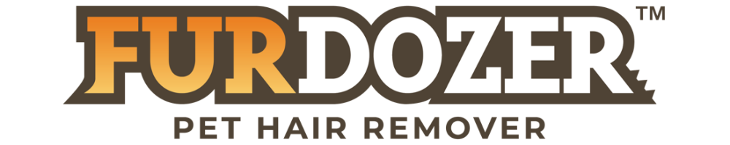

**About Neater Pet Brands**

Since 2009, Neater Pets has been known for highly innovative, solution-based products that enhance the joy of life with pets. The company holds dozens of patents, in the US and abroad, for award-winning products like the Neater Feeder and Neater Scooper. Neater Pets products have been featured on national TV broadcasts like Good Morning America and The Today Show and have appeared for years on QVC in the US, UK, Germany, and Italy. Visit www.NeaterPets.com to see the company’s complete product line.

# For more information (Press or Buyers): For more information on the FurDozer, visit:

Jackie Becattini www.neaterpets.com/furdozer

877-917-PETS

[jbecattini@neaterpets.com](mailto:jbecattini@neaterpets.com)