## 

## FOR IMMEDIATE RELEASE

**Neater Pets Announces Launch of New Product**

***Lift N’ Bag Dog Pooper Scooper***

***with Trap Door***

***Lift and bag dog multiple poop piles with one hand and one bag***

**At the Inspired Home Show in Chicago, Illinois, March 2-4, 2025**

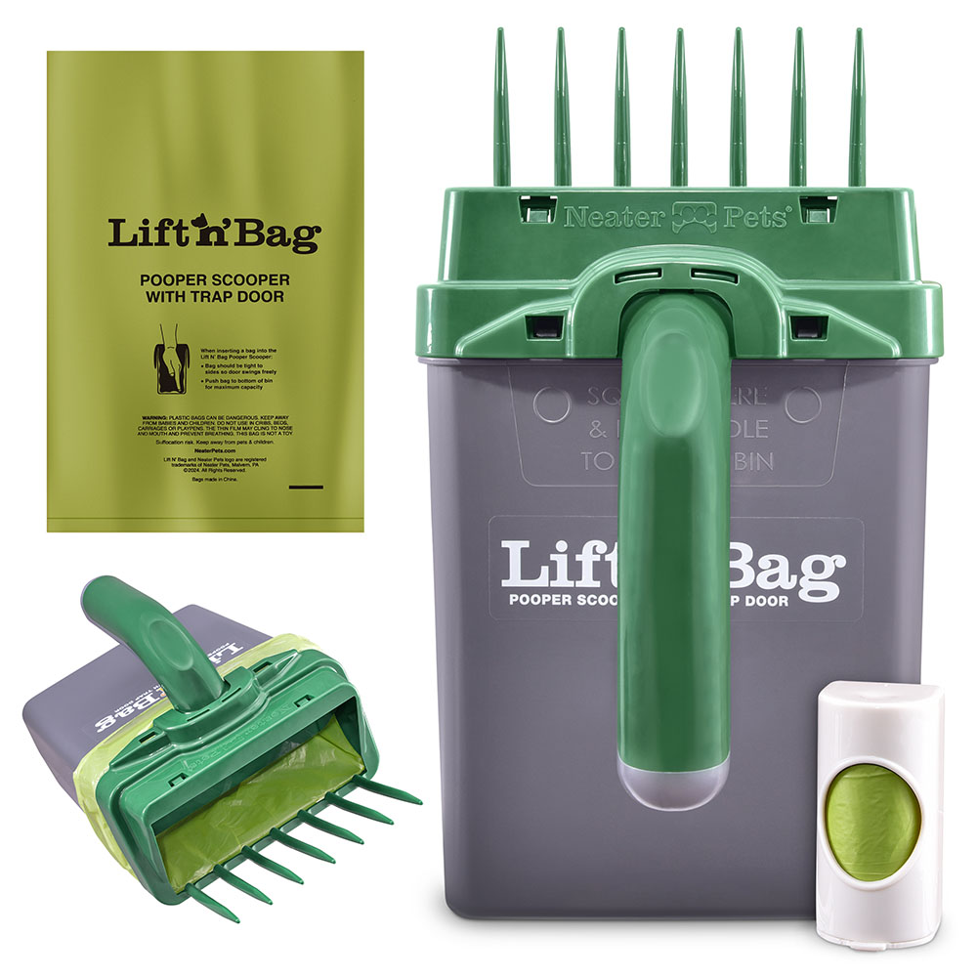

**Malvern, PA – January 21st, 2025** – Neater Pets is proud to unveil its latest innovation at the Inspired Home Show 2025 – the Lift N' Bag Dog Pooper Scooper with Trap Door. This direct-to-bag pooper scooper is designed for one-handed use. Simply slide the tines under dog waste, lift, and the waste is deposited directly into the bag. The trap door closes between scoops, preventing any waste from falling out, so you can pick up multiple piles using just one bag—saving money and reducing plastic waste.

Building on the success of the Neater Scooper direct-to-bag litter scoop, Neater Pets wanted to apply the same concept to dog waste, and the Lift N’ Bag was born.

“I love my dogs, but cleaning up after them in the backyard has always been a hassle,” said Fernando Becattini, Jr., President and CEO of Neater Pets. “Current options, like claw scoopers, end up smearing waste and damaging the grass. Rakes and bins are cumbersome to carry. I wanted a solution that would be easier to use, create less mess, and reduce plastic waste. After two years of design and development, we created the Lift N' Bag. It’s a tool that lifts and bags waste with one hand, with minimal mess, and requires only one bag to clean up 5-10 piles. The initial response from customers has been amazing.”

The Lift N’ Bag is available now at NeaterPets.com, Amazon, and select retailers, starting at $22.99.

-###-

**About Neater Pet Brands**

Since 2009, Neater Pets has been known for highly innovative, solution-based products that enhance the joy of life with pets. The company holds dozens of patents, in the US and abroad, for award-winning products like the Neater Feeder and Neater Scooper. Neater Pets products have been featured on national TV broadcasts like Good Morning America and The Today Show and have appeared for years on QVC in the US, UK, Germany, and Italy. Visit www.NeaterPets.com to see the company’s complete product line.

# For more information (Press or Buyers): For more information on the FurDozer, visit:

Jackie Becattini www.neaterpets.com/furdozer

877-917-PETS

[jbecattini@neaterpets.com](mailto:jbecattini@neaterpets.com)