**FOR IMMEDIATE RELEASE**

**Neater Pets Introduces**

***Neater Scooper XL — Scoop-to-Bag Litter System for Large Cats & Multi-Cat Households***

**At The Inspired Home Show in Chicago, Illinois, March 3-5, 2025**

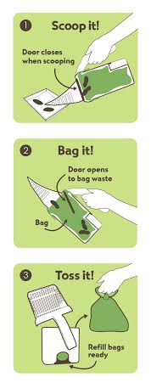 **MALVERN, PA. —February 17, 2025 —** Fernando Becattini, Jr., President and CEO of

Neater Pets, is pleased to introduce the Neater Scooper XL, Scoop-to-Bag Litter System

for Cats at SuperZoo, adding a new larger size to our Neater Scooper Product Line.

Neater Scooper is the easiest way to clean your cat’s litter box with JUST ONE HAND. The

Neater Scooper’s patented design has combined Scooping and Bagging into one motion

with its attached waste bin and clever trap door design. With a simple tilt of the wrist

upward, the trap door opens to deposit waste directly into the waste bin – tilt your wrist

downward to scoop again, and the trap door closes so previously scooped waste stays

inside the bin. Neater Scoopers eliminate the need to touch soiled bags, making them

much more sanitary than other litter scoops. The Neater Scooper XL also features a new

tine design that makes for quick sifting and less dust.

“We are thrilled to introduce the Neater Scooper XL to cat owners. The worst chore of having a cat is scooping the litter. The Neater Scooper is easier, cleaner, and more sanitary, and now the XL can handle the waste of more than just one cat. The Neater Scooper XL perfectly fits our product line and our company philosophy…creating products that make life with pets Neater!” said Becattini, Jr.

The Neater Scooper comes in five color choices: Gray, Navy, Sage Green, Purple, and Pink. The suggested retail price of each Neater Scooper XL with 15 Pet Waste Bags plus a bag dispenser will be $29.99. Neater Scooper Pet Waste Bags Refill Boxes will be sold. Neater Scooper XL is Made in the USA.

For more information regarding this release, media samples, interviews, or images, please contact Jackie Becattini at Neater Pets, 800.917.PETS or [jbecattini@neaterpets.com](mailto:jbecattini@neaterpets.com). You can also visit [www.NeaterPets.com](http://www.NeaterPets.com).

-###-

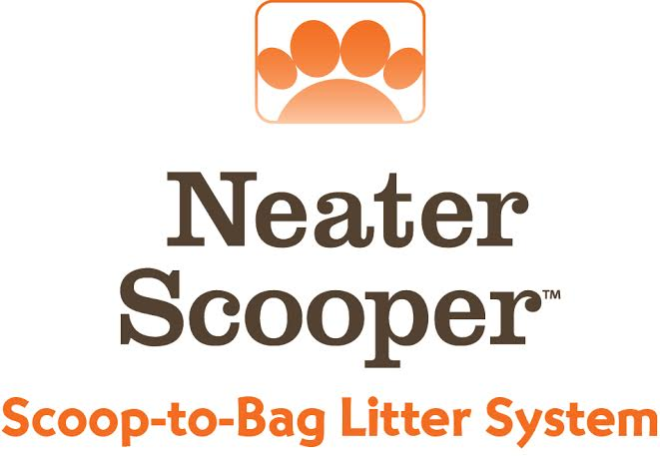

**About Neater Pet Brands**

Since 2009, Neater Pets has been known for highly innovative, solution-based products that enhance the joy of life with pets. The company holds dozens of patents, in the US and abroad, for award-winning products like the Neater Feeder and Neater Scooper. Neater Pets products have been featured on national TV broadcasts like Good Morning America and The Today Show and have appeared for years on QVC in the US, UK, Germany, and Italy. Visit www.NeaterPets.com to see the company’s complete product line.