

**FOR IMMEDIATE RELEASE**

Jonisha Serra

Marketing Coordinator, [jonisha@portstyle.com](mailto:jonisha@portstyle.com)

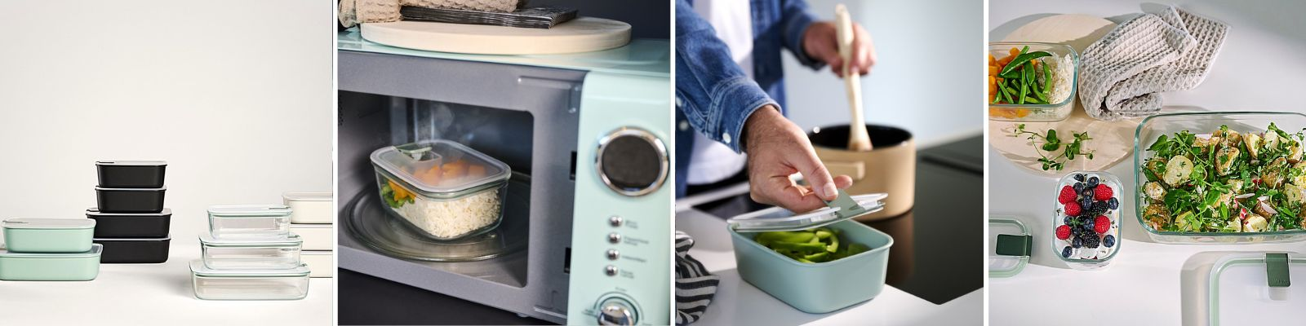

**MEPAL’S EASYCLIP RECTANGULAR GLASS BOX: THE ULTIMATE STORAGE SOLUTION FOR EVERY KITCHEN**

**TORONTO, ON [February 03, 2025]** – Port Style Enterprises Inc., a leader in distributing sustainable and innovative kitchenware, is excited to showcase Mepal's EasyClip Rectangular Glass Boxes at The Inspired Home Show 2025, held at McCormick Place in Chicago, IL, from March 2 to March 4, 2025. Visit us at booth #S817

This practical and multifunctional storage solution is made of durable borosilicate glass, making it perfect for everything from meal prep to storage, whether in the fridge, freezer, microwave or oven. The EasyClip Rectangular Glass Box is designed to keep food fresh with one simple click – sealing in the aroma and flavors.

EasyClip combines the best of modern design and high functionality. With its leakproof, airtight seal, this storage container ensures your food stays fresh longer. The lid features a unique steam vent, perfect for microwave use when defrosting or reheating meals.

The versatile glass option is safe for oven use (up to 900°F / 550°C ) and microwave, making it perfect for reheating meals or preparing dishes. The box is stackable and compact, offering modular storage for your kitchen. Plus, the plastic lid with a steam vent makes it microwave-safe.

We’re proud to offer Mepal’s EasyClip Rectangular Glass Box to our customers. With its innovative one-click closure, modular design, and practical features like the steam vent and oven-safe glass option, EasyClip has received international recognition, including the UK Excellence Award, and has ranked [Number 1 in the Swiss industry ranking](https://www.test.de/Test-Frischhalteboxen-Glas-schlaegt-Plastik-6052991-0/). It’s the ideal solution for anyone looking to store, cook, and enjoy food with convenience and style.

The EasyClip Rectangular Glass Box is available in five sizes, with it’s retail pricing ranging between $20 - $50, offering versatility for various storage needs. All sizes are made with borosilicate glass, and the containers are microwave, dishwasher, and freezer safe.

EasyClip Rectangular Glass Box Pricing:

* EASYCLIP Rect Glass Box 250ml
* EASYCLIP Rect Glass Box 700ml
* EASYCLIP Rect Glass Box 1000ml
* EASYCLIP Rect Glass Box 1500ml
* EASYCLIP Rect Glass Box 2250ml

***The EasyClip Rectangular Glass Box collection is available at*** [***https://portstylewholesaleusa.com/***](https://portstylewholesaleusa.com/)

**About Mepal**

For over 70 years, Mepal has been a trusted name in crafting durable plastic consumer goods in the Netherlands. The company has pioneered the development of innovative plasticware for storing, serving, and organizing, all under one roof. With a legacy of design excellence, Mepal integrates functionality and modern aesthetics to enhance everyday dining experiences. Mepal is also certified as a B Corporation, joining a global community committed to upholding the highest standards of social responsibility, sustainability, and transparency.

**About Port Style**

Port Style Enterprises Inc. is a leader in distributing sustainable kitchenware and home solutions, partnering with forward-thinking brands like Mepal to bring innovative, functional products to retail, wholesale, and consumer platforms across USA and Canada with a passion for design and functionality, Port Style works to provide reliable, efficient products that elevate the kitchen and home experience.

**Marketing Contact**

Jonisha Serra

[jonisha@portstyle.com](mailto:jonisha@portstyle.com)

Marketing Coordinator