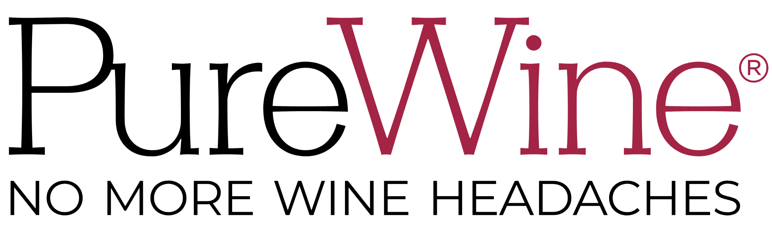

**Raise a Glass to PureWine® With Its #1-Selling Wine**

**Purifiers at The Inspired Home Show and Expo West in March**

*The award-winning brand and Amazon favorite brings its latest collections to the shows,*

*debuting retail displays of its popular Wand colors in Gold and Eco-White.*

[**PureWine®**](https://drinkpurewine.com)is gearing-up for an event-filled March as it unveils its newest products at **The Inspired Home Show** in Chicago on March 2-4 (*South Hall, Booth #S820*) and **Expo West** in Anaheim on March 5-7 (*Hall D, Booth #3898*).

For the first time, PureWine will offer a selection of its most popular Wand colors (Gold, Eco-White ) in new retail displays. Retailers will get a preview of the following new products available to them:

* Gold Wand Singles Counter Display (50 Wands)
* Eco-White Wand Singles Counter Display (50 Wands)
* The Wand USA 30-Pack (Red, Blue, Silver Wands)
* Silver Wand 3-Pack Clip-strips

The singles displays are top sellers at retail, previously in the Classic Silver Wands. The USA 30-Pack was an online exclusive and became a best-seller during summer, especially during the Fourth of July festivities.

“We’re thrilled to return to both shows and give attendees an exciting reason to stop by our booths and look at our latest offerings,” said co-founder Derek Meadows. “From our entry into more sustainable options with the Eco-Wand made from renewable biomaterials that safely decompose to expanding our retail POS, we’re pioneers in the field and always look forward to meeting existing and new customers face-to-face each year at these shows. PureWine is in over 4,000 retail stores and growing, happily spreading the PureWine Advantage to people across the globe!”

The original wine purifier, PureWine has sold over 25-million units and received over 10,000 five-star reviews. For the past four years, the brand has been the World's #1-selling wine purifier and the top-selling wine accessory on Amazon. The brand’s Phoenix Reusable Wine Purifier and Eco-White Wand both won the prestigious Green Good Design award for Sustainability.

PureWine was founded by Derek and his father, Dr. David Meadows, to improve the wine-drinking experience with a collection of purifiers that remove histamines and sulfites without changing the taste of the wine. By purifying red, white, and sparkling wines while enhancing the wine's natural flavor, aroma, and color, wine enthusiasts avoid common triggers like unwanted wine allergies and sensitivities. For more information, visit [drinkpurewine.com](https://drinkpurewine.com).

###

**About PureWine:** PureWine Inc. was founded in 2014 by father and son team from Texas, Dr. David Meadows and his son Derek. Both suffered from headaches and other allergic reactions related to their favorite wines. Instead of “whining” about their problems, they turned to the science of wine to create a patented technology that selectively removes histamines and sulfites without otherwise changing the chemistry of wine.

In 2016, the duo launched the first PureWine product, The Wand, for a glass of wine, followed in mid-2018 by The Wave for a bottle of wine. After eight years and more than 25-million products sold, the brand has received 10,000+ five-star reviews online and were the top-selling wine accessories on Amazon in 2021-2024. They are continuously rated a top wine gift by leading media, including *Good Morning America, The Today Show, BuzzFeed, Oprah Daily, Real Simple, Cosmopolitan, PopSugar, Wine Spectator, Food & Beverage* and *Forbes*, among others.

The mission of PureWine is to end the problem of wine allergies and to enable more people to enjoy the unique pleasures and health benefits of wine. Experiencing record growth the past two years, the brand’s prior innovation is the award-winning Phoenix Reusable Wine Purifier,introduced Fall 2021. Find PureWine at Total Wine & More, Costco.com, Walmart, BevMo!, Wegmans, Raley’s, ABC Fine Wine & Spirits, Buc-ee’s, Binny’s, Sur La Table, and World Market.

PureWine's commitment to sustainability extends throughout its operations, from sourcing sustainable materials and products to implementing energy-efficient practices and reducing its carbon footprint. Follow them on [**Instagram**](https://www.instagram.com/drinkpurewine/?hl=en) and [**TikTok**](https://www.tiktok.com/@drinkpurewine).

