
FOR IMMEDIATE RELEASE Contact: Amy Levy Public Relations 310-444-5250

SealVax® LLC, Purveyor of the Leading Technology for Food Freshness, Sustainability, and Flavor, Will Exhibit at The Inspired Home Show 2025.
Experience the Ultimate Kitchen Companions for Food Preservation & Marination in Chicago March 2nd – 4th in Booth S3460

Los Angeles, CA, February 7, 2025…SealVax LLC, a pioneer in kitchen innovation, is thrilled to announce its participation in The Inspired Home Show 2025. North America's premier housewares trade show will be held at McCormick Place in Chicago, March 2-4, 2025 in Both S3460. Formerly known as the International Home + Housewares Show, this highly anticipated event for home and housewares professionals will bring together industry leaders, buyers, manufacturers, and retail executives from over 120 countries. SealVax® will be showcasing its revolutionary food preservation solutions, including their SeasonSeal Container System. Visit SealVax.com
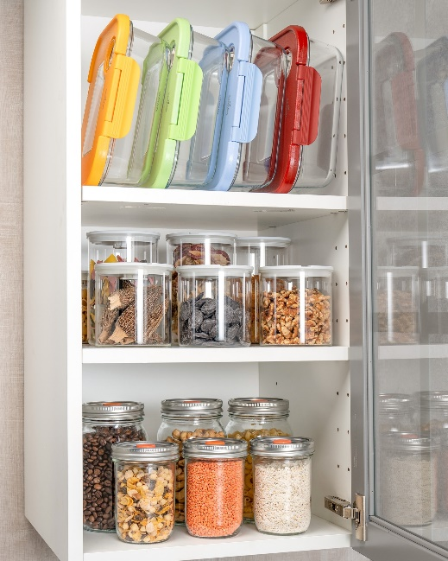
Transform your kitchen with the power of professional-grade technology! Keep food fresh all with a simple seal.

“We are thrilled to be part of The Inspired Home Show,” said Steven Yang, President of SealVax LLC. “Attendees in Chicago will learn how SealVax® enhances the cooking experience with our vacuum cycling technology. For home chefs that are interested in marinating and fast pickling, our R&D team has made the process faster than you ever thought possible. With SealVax, the herbs, spices, and other flavorings can be added to the protein or vegetables inside the groundbreaking SeasonSeal container, and it will be ready for the oven or grill in mere moments,” he shared.
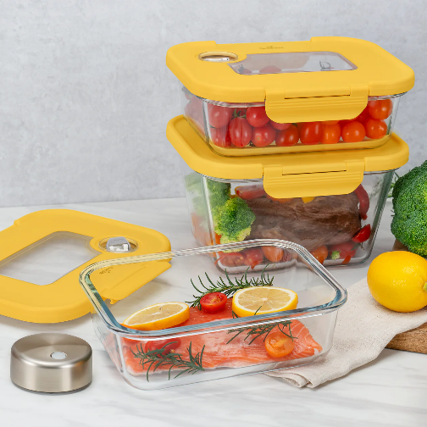
The SealVax patent-pending Season Mode Vacuum cycles vacuum pressure by repeatedly sealing and releasing. This process speeds up marination by gently loosening protein fibers, allowing flavors to penetrate more thoroughly for juicy, tender results.
Freshness and Food Preservation
Did you know that the USDA estimates that US food waste is as high as 30-40% of the food supply? That's a lot of landfills, and a lot of money. The average family of four throws away more than $1,500 worth of food each year!
Visitors to the Inspired Home Show will discover a range of SealVax® solutions (Booth (S3460) designed to keep food fresh up to five times longer than conventional methods. They will learn how to keep dry goods fresh and organized with SealVax’s VOYD Canisters. These patent-pending Vacuum Canisters seal in the goodness and nutrients of anything that fits, but they are especially perfect for coffee, chocolate, flour and more.
Fast Pickling With MasonSeal Jars
Whether you want to enjoy the bounty of your garden right now or extend the life of your farmer’s market haul, with SealVax® MasonSeal Jars, fast pickling is a breeze. Just create your brine, pour it over your fruits or veggies, seal the lid tight, and vacuum! Enjoy it immediately or store it in the fridge for up to two to three weeks. You can even re-vacuum after each use. (Follow all USDA guidelines for fast pickling and food preservation.)
But MasonSeal isn’t just for fast pickling! Use it for any food storage; wet or dry, fridge or pantry. It’s also a drink glass, cocktail shaker, and lunch container. The vacuum button lid makes the classic mason jar even more versatile.
The Very Best Reusable Bags! A Space Saver for Meal Prep, Lunch Boxes, Snacks
SealVax Reusable Vacuum Bags are so versatile and give you an easy way to preserve your foods for longer and save space at the same time! They are perfect for fruits, veggies, proteins and meals or sauces you prep ahead to throw into the fridge or freezer for future use. SealVax Bags are durable enough to use over and over.

Sustainability – More Taste, Less Waste!
SealVax® is proud to emphasize its commitment to protecting the environment by operating in a way that doesn’t harm natural resources. In both its R&D and manufacturing practices, SealVax® also considers the social and economic impacts of its actions. The company’s reusable bags and canisters are made from materials certified by the Global Recycle Standard (GRS), reflecting the company’s dedication to reducing plastic waste and supporting sustainability.
Reduce, Reuse, Recycle & Enjoy a Healthier Life, and a Happier Planet with SealVax®
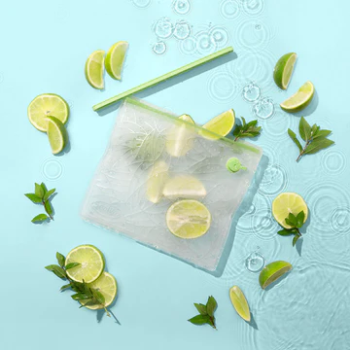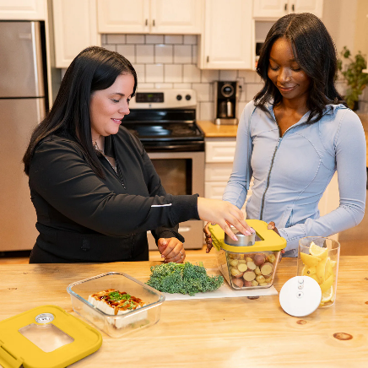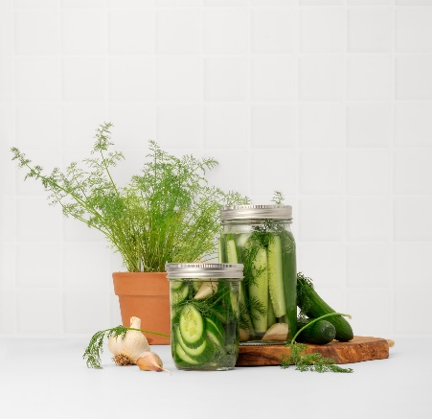
About SealVax LLC
SealVax® is dedicated to creating innovative kitchen solutions that extend the life of food while minimizing environmental impact. Their range of sustainable products includes vacuum sealing bags, canisters, and containers designed to preserve freshness and reduce food waste. SealVax® is committed to helping home chefs and busy families enjoy fresh, flavorful meals with ease.
SealVax® products are available for purchase on SealVax.com and Amazon.com.
Website: www.sealvax.com
Facebook: https://www.facebook.com/SealVax
Instagram: https://www.instagram.com/sealvaxsystem/
Media Inquiries:
Please reach out to Amy Levy Public Relations at amy@amylevypr.com or call 310-444-5250 to:
- Get additional information about SealVax® products.
- Schedule an appointment to visit booth S3460 at The Inspired Home Show.
- Request product samples for your story or broadcast.
- Receive high resolution photos.
- Schedule an interview with one of our company principals.

